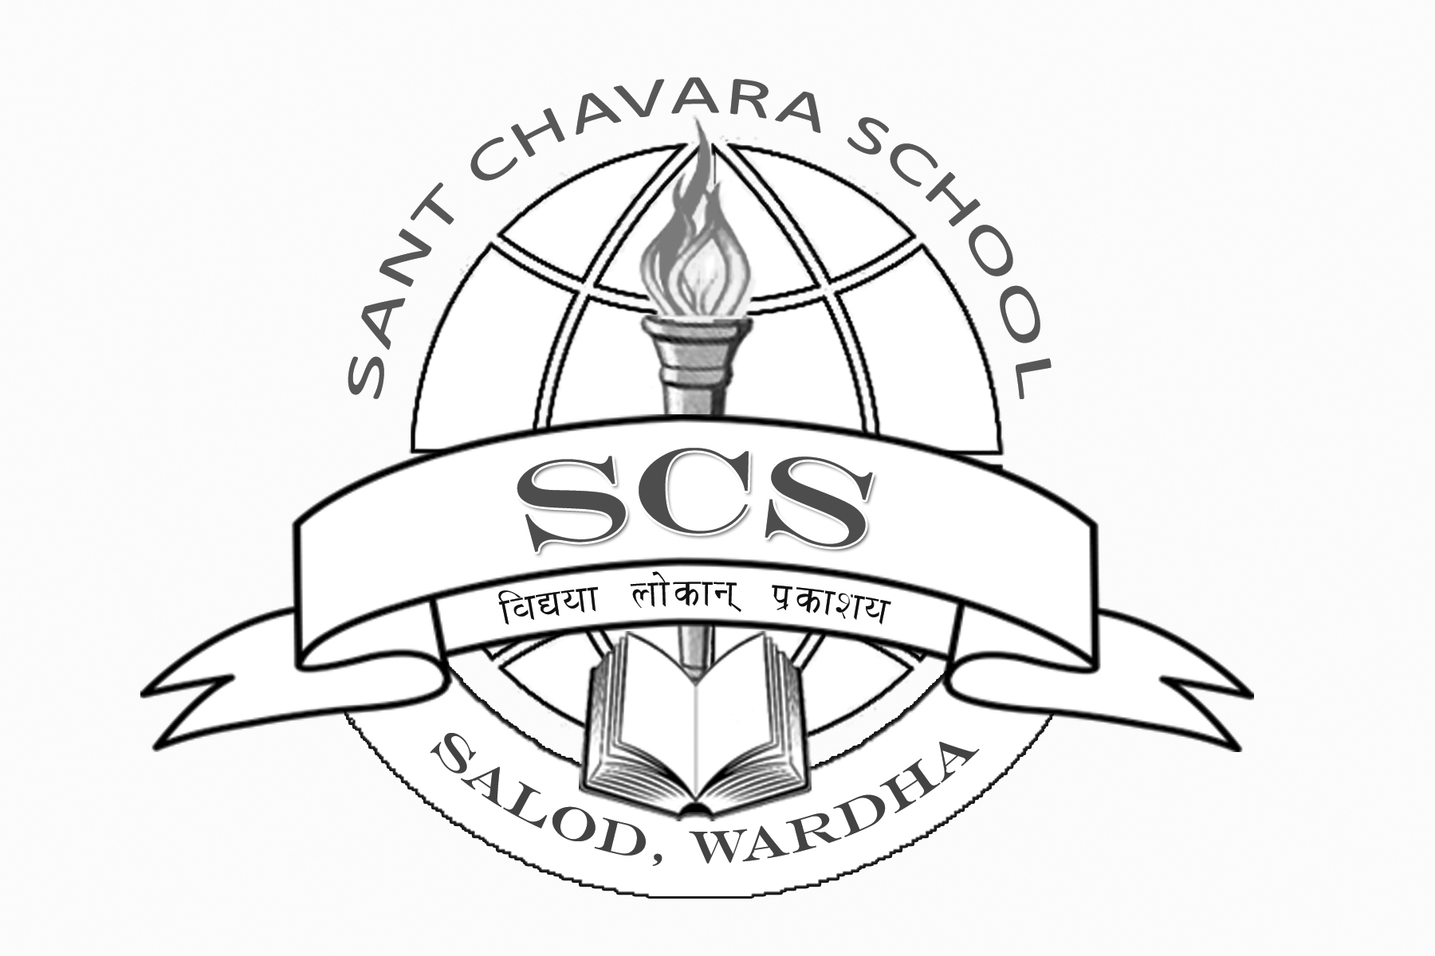

**Name :- ____________________________________________________ Roll No.:- ___________ Marks : 10**

**Std : 2nd (___) (Date : 20/07/17) Subject :- Hindi Duration : 1 Hrs.**

**SANT CHAVARA SCHOOL, SALOD(H), WARDHA**

**1ST  PERIODIC TEST(2017-18)**